2.CREATE AN EC2 INSTANCE FOR A REACTJS APPLICATION AND DEPLOY THE APPLICATION AND PROVIDE THE PUBLIC IP FOR IT ALSO ENABLE THE CLOUD MONITORING ON THESE INSTANCES

1. Open the Amazon EC2 console at <https://console.aws.amazon.com/ec2/>.
2. Create an instance and launch the instances through following 7 steps.

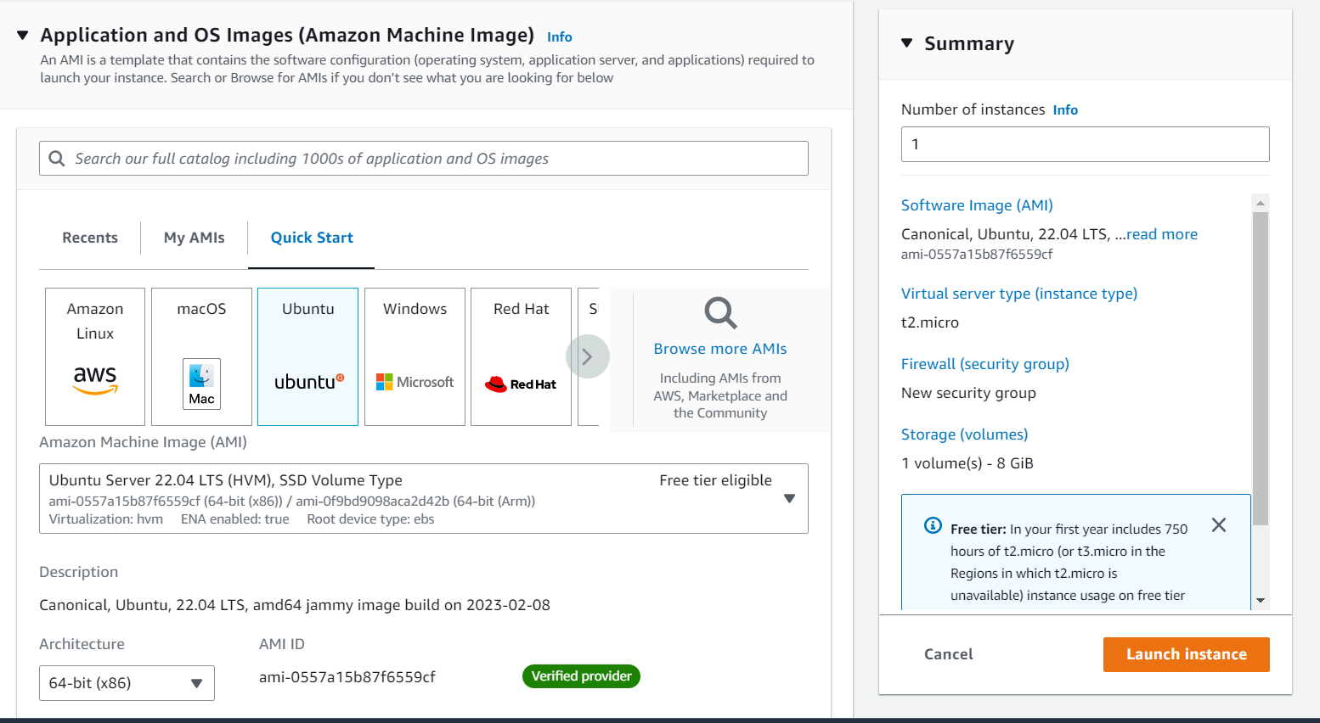

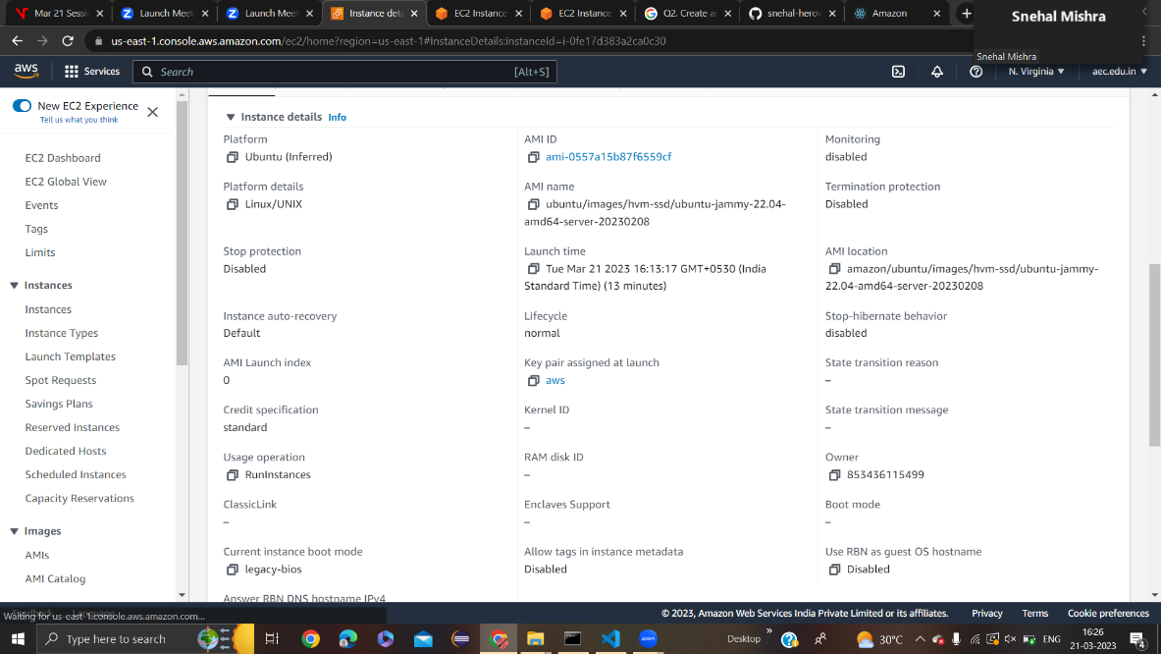

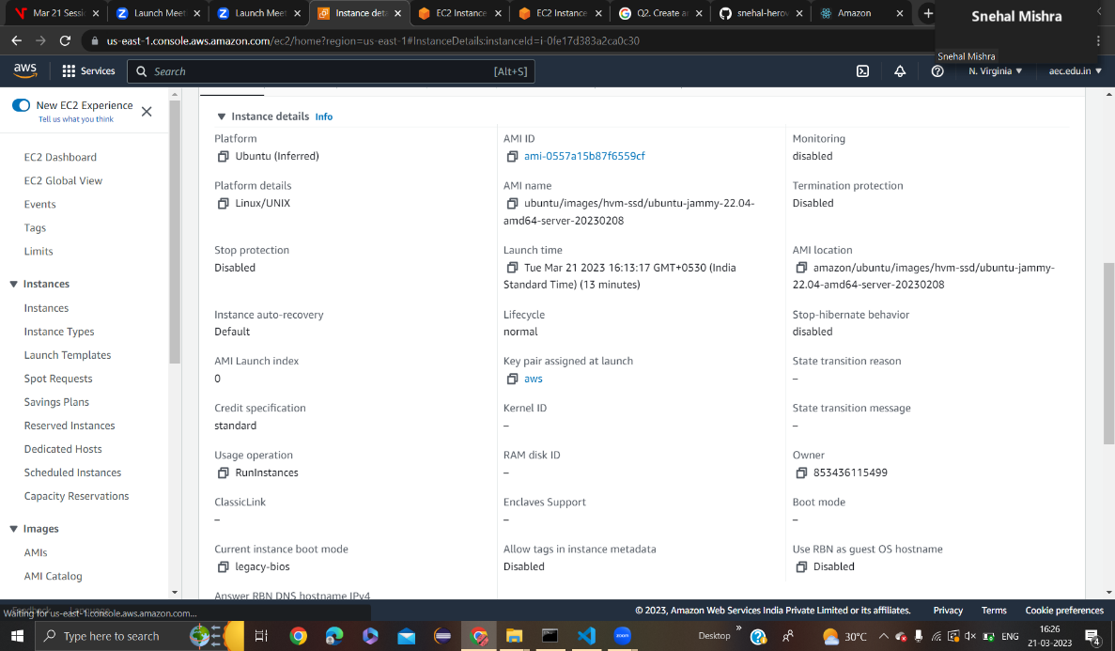

3. Now, click on the launch instance and enter a name for the instance.

4. Here, I named it “react”.

5. Now, select Ubuntu as AMI(Amazon Machine Image) and select t2 micro.

6. Select auto assign public ip.

7. We can keep the network settings as its default one.

8. f we wish to change the network settings, then we can do changes too.

9. Now connect the instance.

10. Now, run the command sudo apt-get install nodejs.

11. This command will install the nodejs.

12. ->Now, run the command “npm i” npm install is the command used to install the dependencies listed in a project's package. json file.

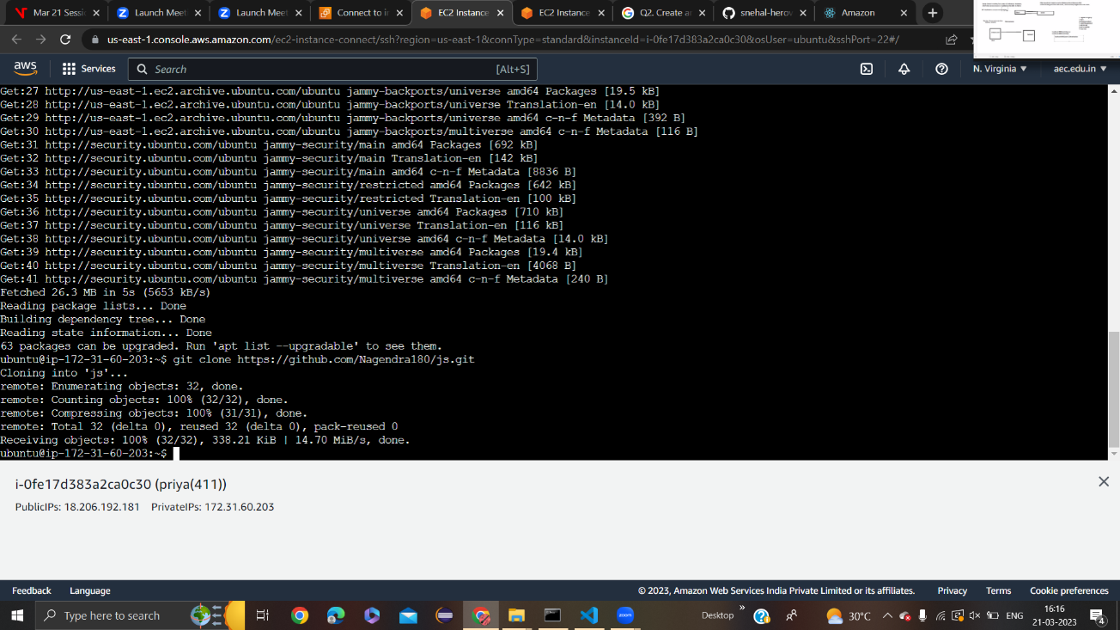

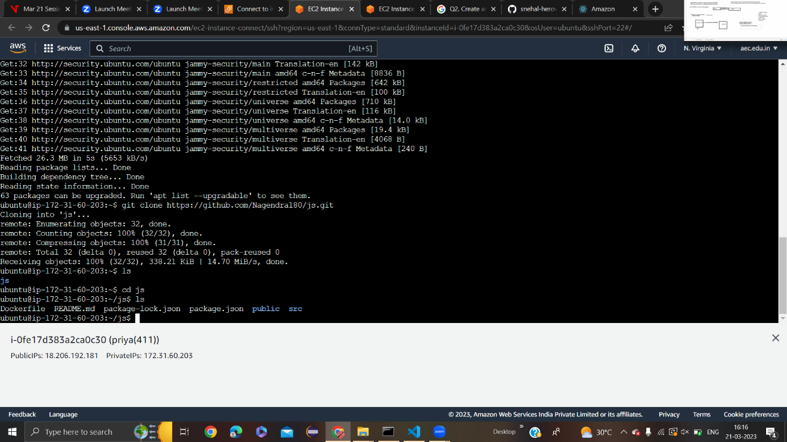

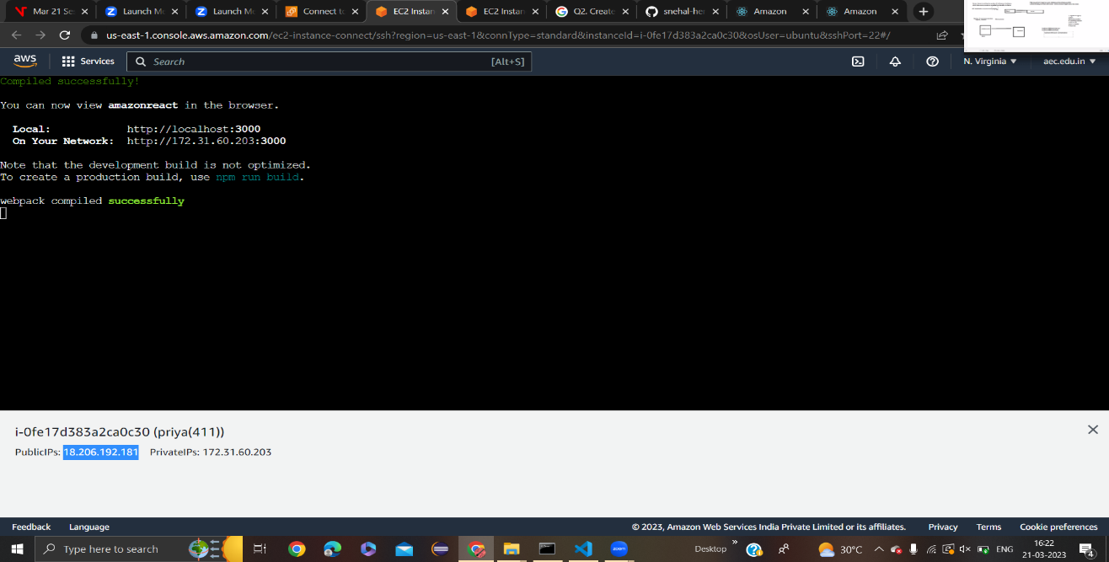

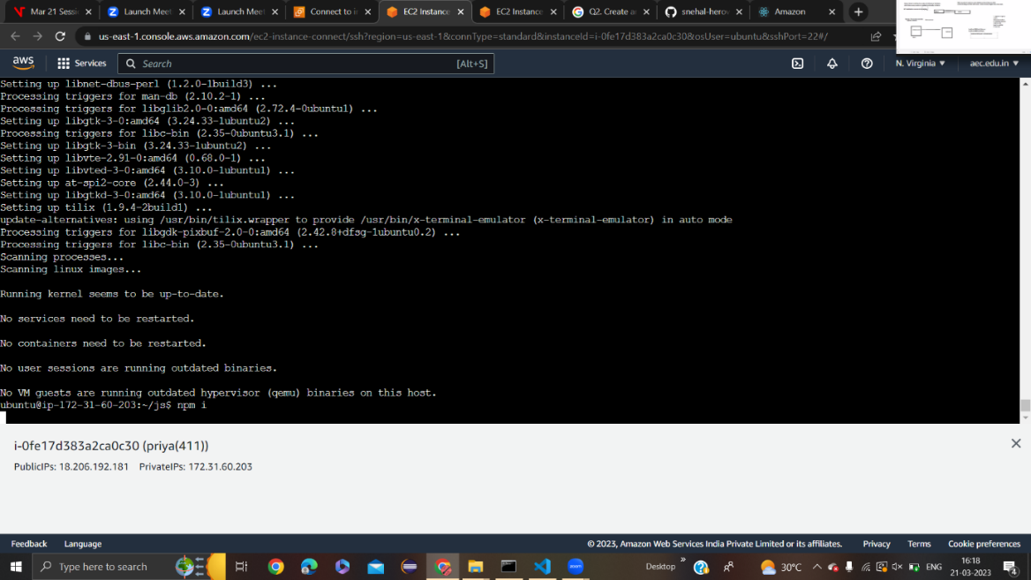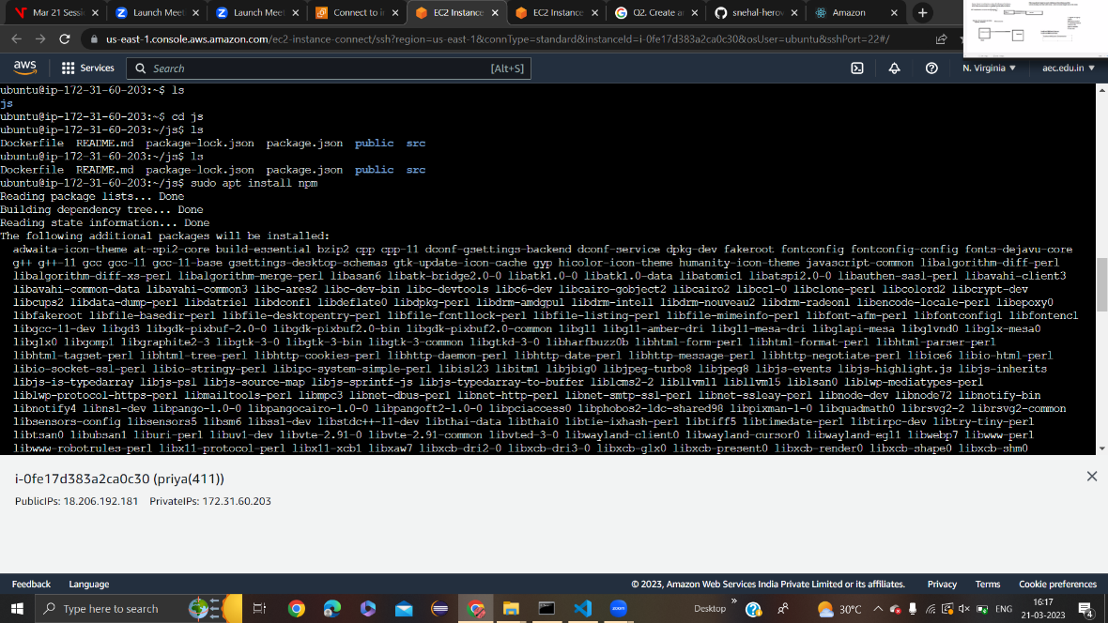

* CREATING THE EC2 INSTANCE AND DEPLOYED THE APPLICATION

